
Department of CSE

B.Tech. CSE Trimester -5

Roll Number- 2520030048
Name- Teja Hasini Reddy

Cloud Infrastructure and Services
25CS2206E

LAB RECORD
2026

Experiment -1b
AIM: To enable Multi-Factor Authentication (MFA) for an AWS IAM user to provide an additional layer of security during AWS Management Console sign-in.
Description:
AWS Identity and Access Management (IAM) is used to create users and control their access to AWS resources. In this experiment, an IAM user named StudentUser01 was created in the AWS account. The permission review displayed the AWS managed policies AdministratorAccess and IAMUserChangePassword.
A virtual MFA device was then configured using an authenticator application. The application generates a time-based six-digit code. During sign-in, the IAM user must provide the username, password, and current MFA code. This adds a second verification step to protect console access.
Steps:
1. Sign in to the AWS Management Console and open the IAM service.
2. Select Users, click Create user, and enter the username StudentUser01.
3. Enable AWS Management Console access and configure the console password.
4. Set the permissions as shown in the experiment review screen. The displayed policies were AdministratorAccess and IAMUserChangePassword.
5. Review the user details and permissions, then click Create user.
6. Use the AWS account ID, IAM username, and console sign-in URL to sign in as StudentUser01. Update the console password if AWS requires it.
7. Open IAM → Users → StudentUser01 → Security credentials.
8. In the Multi-factor authentication (MFA) section, click Assign MFA device. Enter the device name StudentMFA01 and select Authenticator app.
9. Open an authenticator application, scan the QR code displayed by AWS, and enter two consecutive six-digit codes to complete device registration.
10. Confirm that the virtual MFA device is listed as assigned to StudentUser01.
11. Sign out and sign in again using the IAM user credentials. When prompted, enter the current six-digit code from the authenticator application.
12. Verify that AWS Console Home opens under StudentUser01 after MFA verification.
Output:
The IAM user StudentUser01 was created successfully. The permission review displayed AdministratorAccess and IAMUserChangePassword. A virtual MFA device was assigned, and the final sign-in test reached AWS Console Home under StudentUser01. The first sign-in attempt failed; updating the IAM console password resolved the issue.
Recorded AWS details:
AWS Account ID: 839848201044
AWS Region: us-east-1
IAM username: StudentUser01
IAM user sign-in URL: https://839848201044.signin.aws.amazon.com/console
MFA device name: StudentMFA01
MFA type: Virtual authenticator application

OUTPUT – SCREENSHOT EVIDENCE
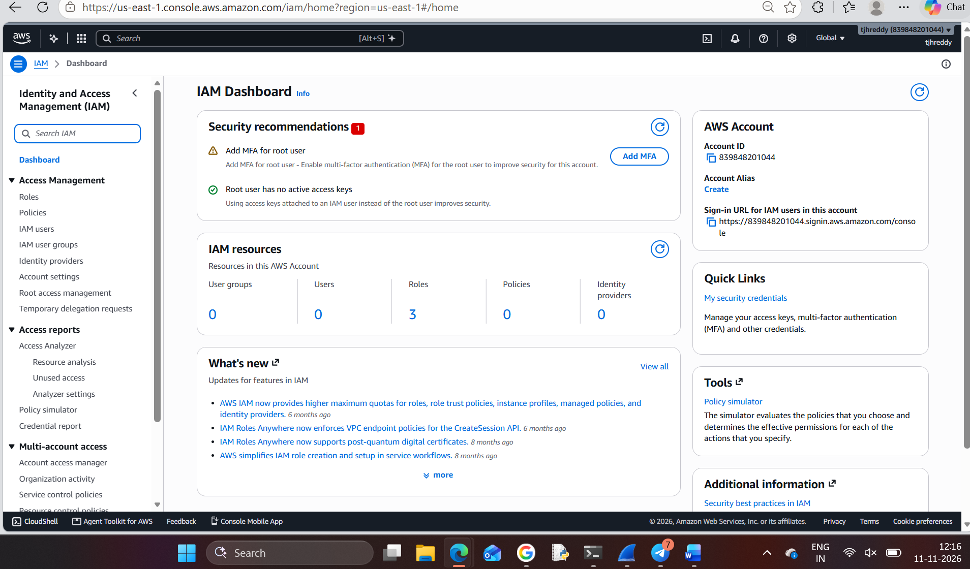
Figure 1. AWS IAM dashboard opened from the AWS Management Console.

OUTPUT – SCREENSHOT EVIDENCE
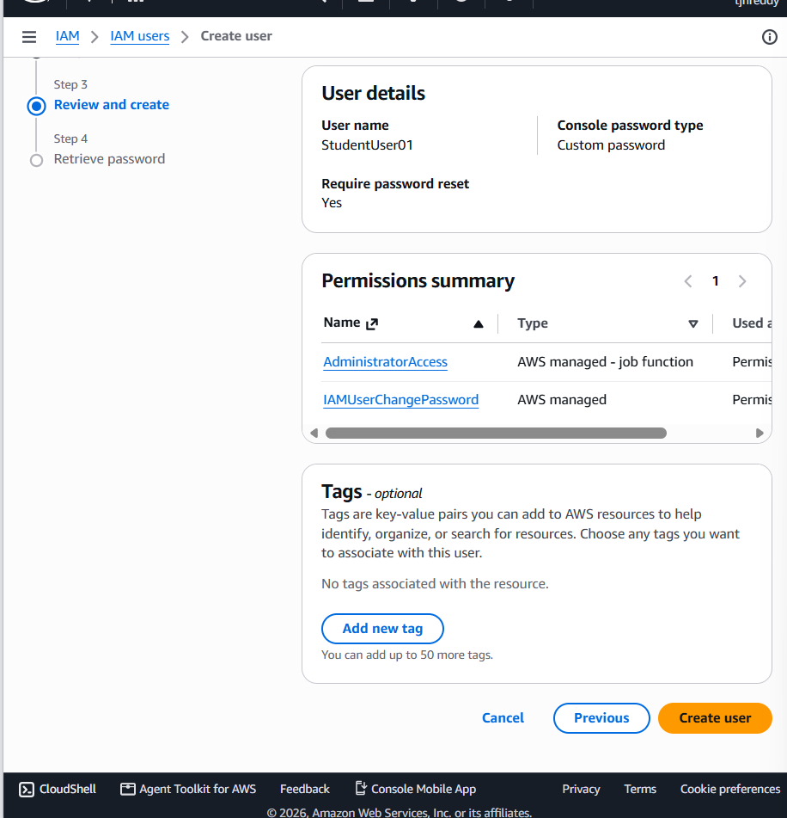
Figure 2. Review and create screen showing the IAM user and attached permissions.

OUTPUT – SCREENSHOT EVIDENCE
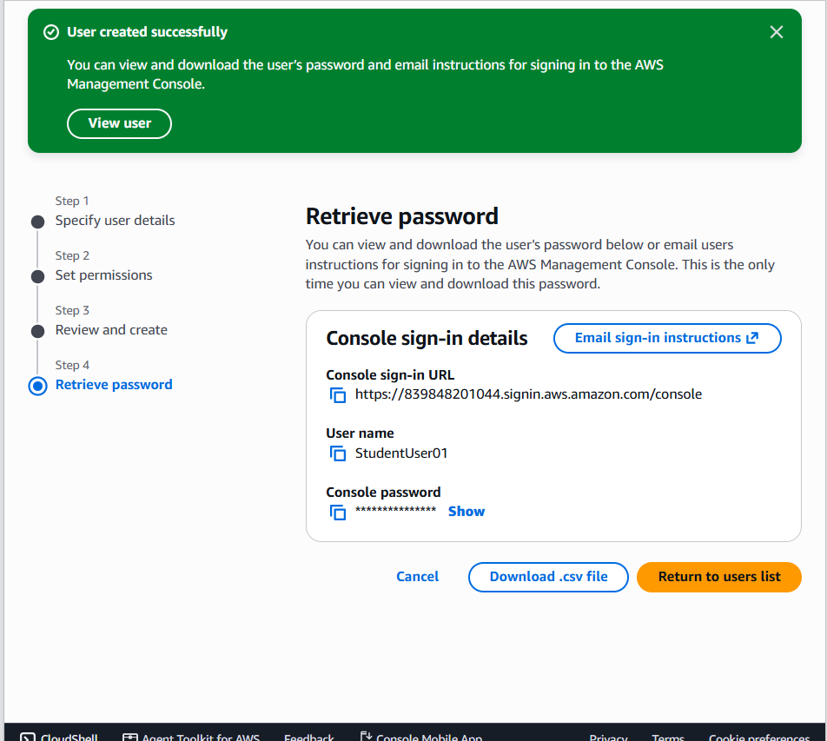
Figure 3. AWS confirmation that StudentUser01 was created successfully; the console password is masked by AWS.

OUTPUT – SCREENSHOT EVIDENCE
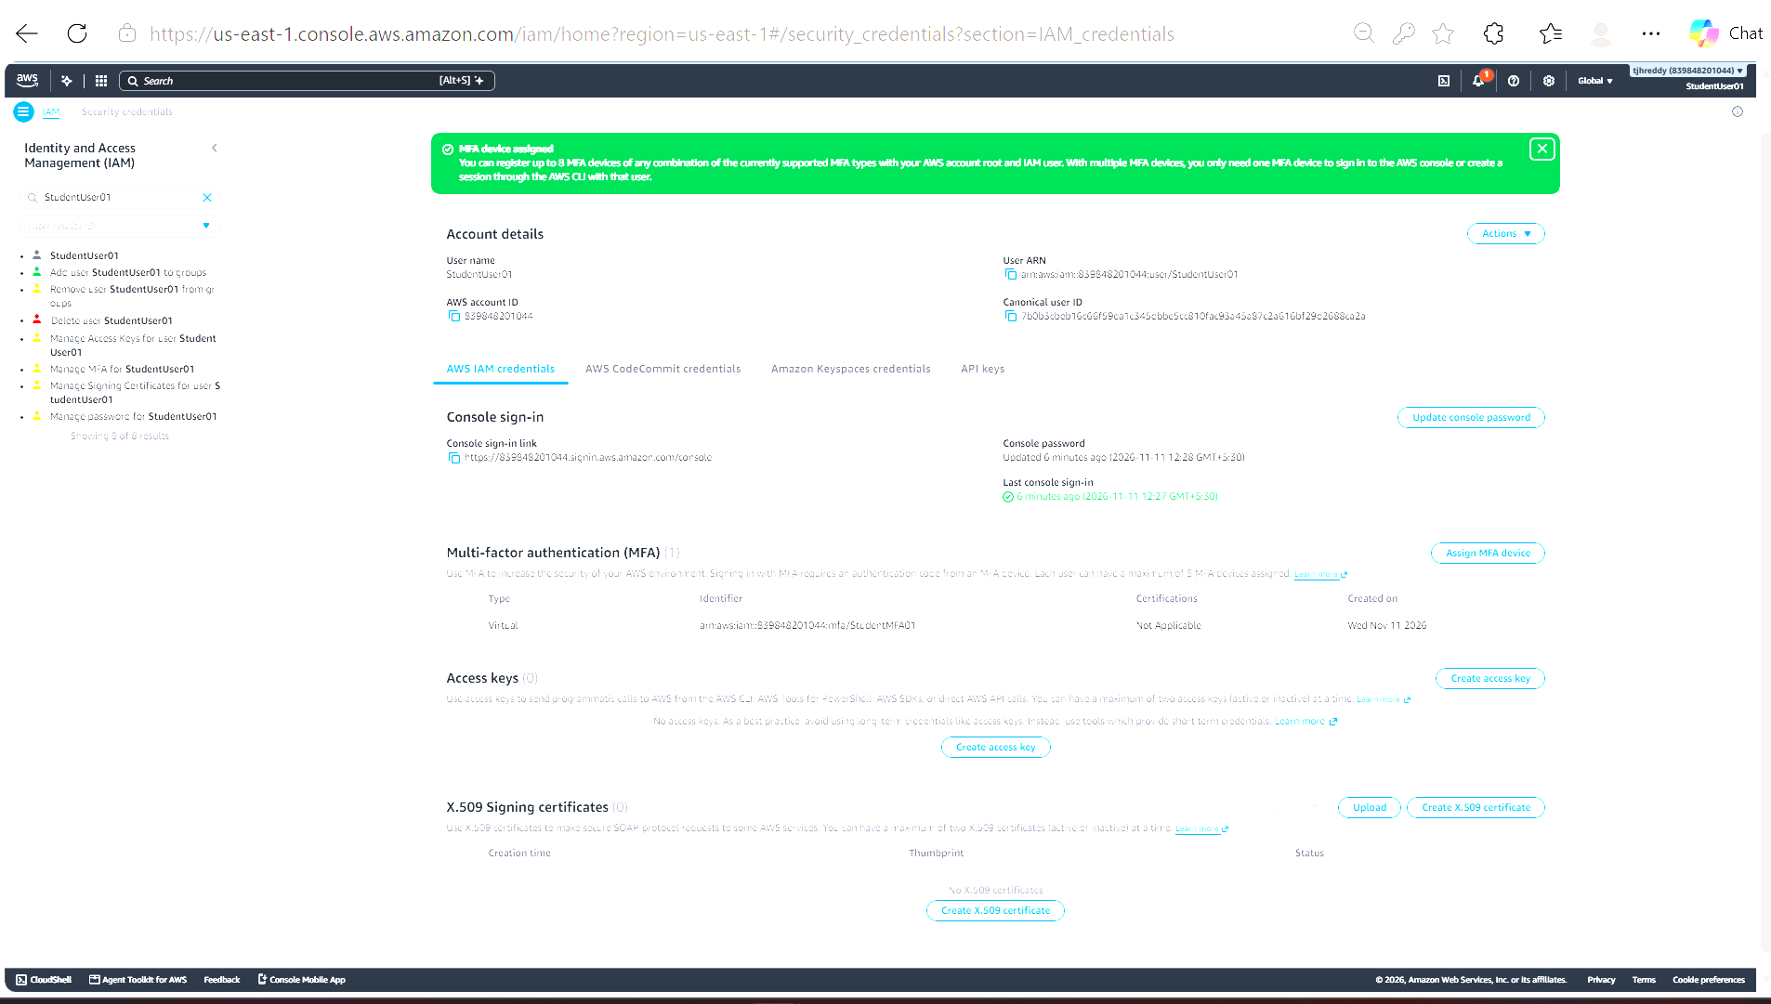
Figure 4. Security credentials page showing that the virtual MFA device was assigned to StudentUser01.

OUTPUT – SCREENSHOT EVIDENCE
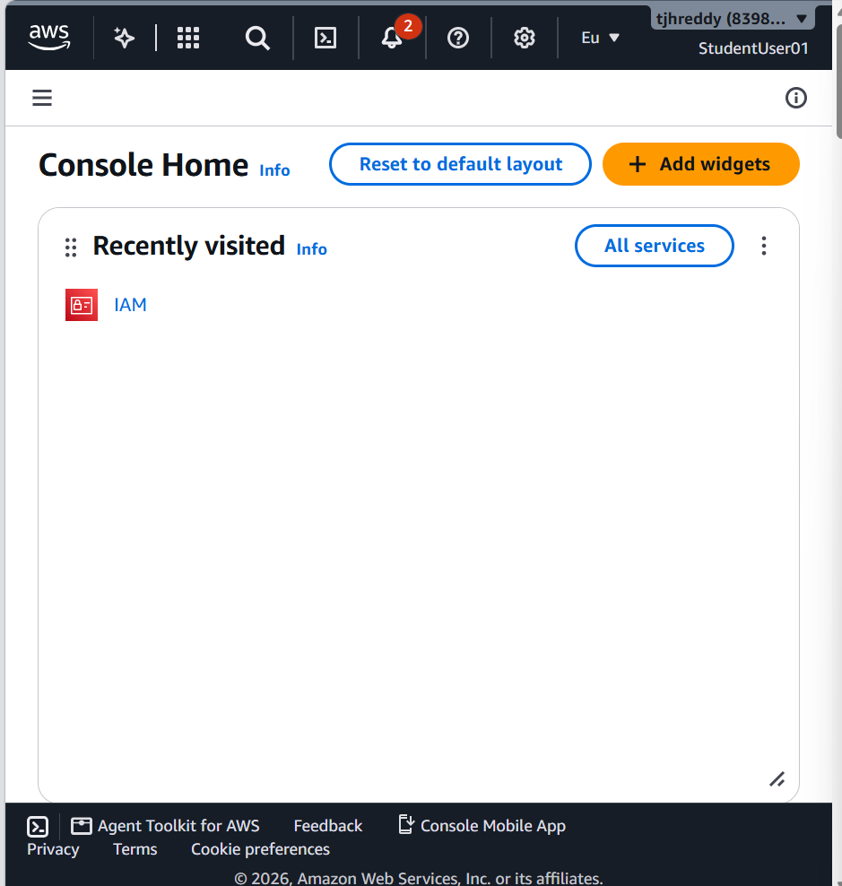
Figure 5. AWS Console Home displayed after signing in as StudentUser01.

